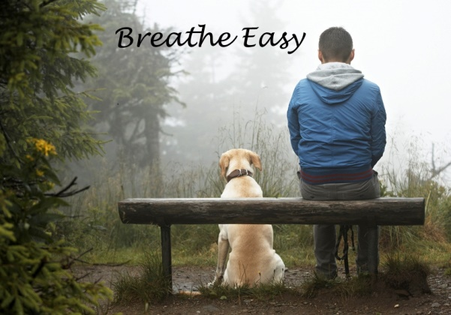

8 week Mindfulness Course
led by Ratnadevi (Dr. Luise Holtbernd)
8 weekly sessions, starting Wed 13 May 2020, 7-9pm; plus day retreat on 4 June, 10 am– 4pm
Venue: Glasgow Westend
cost £240, including course manual, pre-course chat and online support
An introductory mindfulness course for people who want to learn to enjoy the moment and breathe easy, get a handle on reducing stress, feel more centered and calm, be more connected with the body and nature, gain a larger perspective, understand that we are not our thoughts, feel more of a heart-connection with ourselves and others, develop more clarity on what really matters to us and live from those deeper values.
Hundreds of trials have shown the effectiveness of the mindfulness approach on mental and physical health and wellbeing. There is a clear relation between the daily formal practice of mindfulness and improvements in emotional resilience, the ability to focus, better relationships and an enhanced immune system.
The main components of this programme are mindful movement, body-scan meditation, sitting meditation of various kinds and mindful communication. There are also informal exercises that help us bring mindfulness into everything we do, such as brushing our teeth or answering the phone. The course is based on MBCT (mindfulness-based cognitive therapy), MBSR (mindfulness-based stress reduction), Compassion teachings from Tara Brach (and others) and NVC (nonviolent or compassionate communication, Marshall Rosenberg), as well as the newly developed Mindfulness for Life programme.
Ratnadevi is one of the most experienced mindfulness teachers, trainers and mindfulness supervisors in Scotland. The course would be suitable as part of entrance qualification for teacher training.

‘Through the mindfulness course I have found a place of stillness within me. A place which I can choose to link into and which has given me the tools to changing the way I live my life.’
Annemieke, counsellor

‘Ratnadevi is an inspiring teacher who brings both great compassion and the wisdom of long experience’
Dan Markus, consultant clinical psychologist

Before booking please read the information on mindfulness on www.livingmindfulness.net. The course is not a substitute for therapy. Please contact Ratnadevi for a pre-course chat before you make your booking.
contact Ratnadevi at 0141 9468096 or info@livingmindfulness.net.
To book please send the full amount or a non-returnable deposit of £100 together with the form below. Cheques to be made out to L. Holtbernd and it is possible to make a bank transfer to L. Holtbernd, 00172480, 83-21-37 (please give your name as reference). You will receive a letter of confirmation and more info.
Any balance to be paid at arrival, by cheque or in cash.
Postal address: Ratnadevi, 2/1 14 Garrioch Drive, Glasgow G20 8RS. info@livingmindfulness.net tel 0141 9468096
….………………………………………………………………………………………………………………………………………
Booking form
Please book a place for me for 8 week Mindfulness course ‘Breathe easy’ starting 9 Oct 2019

Name…………………………………………….………………email…………………………………………

phone………………………
My payment is £100/ £240 by bank transfer/ cheque (please delete as required)

Thanks.

